WOMEN SAFETY TRACKER: A JOURNEY PROTECTION AND EMERGENCY ALERT SYSTEM
A REPORT SUBMITTED IN
PARTIAL FULFILMENT OF THE REQUIREMENTS FOR
INTERNSHIP
By
GOKUL R S
Adi Shankara Institute of Engineering and Technology (ASIET), Kalady

DURING
1 May 2026 - 31 July 2026

UNDER THE GUIDANCE OF
Dr. P. Victer Paul

INDIAN INSTITUTE OF INFORMATION TECHNOLOGY KOTTAYAM



Abstract
Personal safety during daily travel remains a serious concern for women in India. Most safety applications are reactive: they send an alert only when the user presses an SOS button, which fails exactly when the user is unable to act. This report presents the design, implementation and evaluation of Women Safety Tracker, a web-based journey protection and emergency alert system developed during an internship at the MINDS Research Lab, Indian Institute of Information Technology Kottayam.
The system works as a dead-man’s switch. Before a journey the user records the destination, vehicle and companions and chooses a four-digit PIN, which starts a 20-minute safety timer. Unless the PIN is entered before the timer and a 30-second alarm grace period expire, an SOS is sent automatically by SMS through Twilio, carrying the journey details and a Google Maps link to the last known GPS position. Further mechanisms include a duress PIN that shows a fake "Tracker is disabled" screen while silently raising the alarm, an automatic SOS after three wrong PIN attempts, battery warnings with automatic SOS at critical charge, a decoy call, safe-route guidance to the nearest hospital or police station, and an audit log.
The front end uses React 18, TypeScript, Vite, Tailwind CSS and Leaflet with OpenStreetMap; a small Express.js service handles SMS dispatch, and the application is deployed on Netlify. An end-to-end test delivered an SOS SMS with the journey context and location link to a contact’s phone. The report also discusses the limits of the prototype, notably its browser-side timer and Twilio trial account, and outlines future work.
Keywords: women safety, journey tracking, SOS alert, duress PIN, geolocation, React, Twilio.
Table of Contents
Chapter 1: Introduction 1
1.1 Background 1
1.2 Problem Statement 1
1.3 Aim of the Internship Project 1
1.4 Objectives 2
1.5 Scope of the Work 2
1.6 Organization of the Report 2
Chapter 2: Literature Review and Background 4
2.1 Domain Overview 4
2.2 Existing Methods and Technologies 4
2.3 Related Research Works 5
2.4 Research Gap / Motivation 5
Chapter 3: Problem Analysis and Proposed Methodology 6
3.1 System Overview 6
3.2 Requirement Analysis 6
3.3 Proposed Methodology 7
3.4 Workflow / Framework 7
3.5 Tools and Technologies Used 9
3.6 Algorithm / Model Description 10
Chapter 4: Implementation 12
4.1 Dataset / Data Collection 12
4.2 Data Pre-processing 12
4.3 Model Development / System Design 12
4.4 Implementation Details 13
4.5 Experimental Setup 20
Chapter 5: Results and Discussion 21
5.1 Performance Evaluation Metrics 21
5.2 Experimental Results 21
5.3 Comparative Analysis 24
5.4 Discussion 24
Chapter 6: Conclusion and Future Scope 26
6.1 Summary of Work 26
6.2 Outcomes Achieved 26
6.3 Limitations 26
6.4 Future Enhancements 27
References 28
Appendix 30
A. Sample Input and Output 30
B. Running the Application 30
C. User Interface Screenshots 30
List of Figures
Figure 3.1: Logical architecture of Women Safety Tracker 8
Figure 3.2: Journey workflow: from set-up to safe completion or automatic SOS 8
Figure 3.3: Sequence of an SOS dispatch 9
Figure 4.1: Landing page of Women Safety Tracker 13
Figure 4.2: "Engineered for Vigilance" feature section 13
Figure 4.3: User dashboard with map and journey controls 14
Figure 4.4: Setup Safety Journey form 14
Figure 4.5: PIN configuration screen (left) and active alarm state with SOS countdown (right) 15
Figure 4.6: "Tracker is disabled" screen shown for the genuine PIN and for the duress PIN 16
Figure 4.7: FAQ entry explaining how the journey workflow works 16
Figure 4.8: FAQ entry explaining the duress PIN 16
Figure 4.9: FAQ entry explaining low-battery behaviour 16
Figure 4.10: Battery low warning 17
Figure 4.11: Battery critical warning with automatic SOS 17
Figure 4.12: Safe route to the nearest hospital 18
Figure 4.13: Safe route to the nearest police station 18
Figure 4.14: Safety log and audit history 19
Figure 4.15: Emergency contact directory 19
Figure 4.16: Location Hub with live map and location history 19
Figure 5.1: Journey set-up with test data (destination Home, Uber, companion Samuel) 22
Figure 5.2: SOS SMS received on the emergency contact’s phone (earlier test message above, main test below) 23
List of Tables
Table 2.1: Gap analysis between common approaches and the proposed system 5
Table 3.1: Functional requirements 6
Table 3.2: Non-functional requirements 7
Table 3.3: Technology stack 9
Table 3.4: Browser APIs used and their role 10
Table 4.1: Data entities and their sources 12
Table 4.2: Battery alert levels 17
Table 4.3: Conditions that trigger an SOS 20
Table 5.1: Evaluation metrics 21
Table 5.2: Test scenarios and observed results 21
Table 5.3: Content of the received SOS SMS 23
Table 5.4: Comparison of approaches (general characteristics) 24
Table A.1: Sample journey input 30
List of Abbreviations
Abbreviation | Expansion
API | Application Programming Interface
CSS | Cascading Style Sheets
GPS | Global Positioning System
HTTPS | Hypertext Transfer Protocol Secure
IEEE | Institute of Electrical and Electronics Engineers
IIIT | Indian Institute of Information Technology
JSON | JavaScript Object Notation
MINDS | MINDS Research Lab, IIIT Kottayam
NCRB | National Crime Records Bureau
OSM | OpenStreetMap
PIN | Personal Identification Number
REST | Representational State Transfer
SMS | Short Message Service
SOS | Emergency distress signal
UI | User Interface

Chapter 1: Introduction

1.1 Background
Safety during everyday travel is a persistent concern for women in India. The National Crime Records Bureau reported 4,45,256 cases of crime against women in 2022, a rise of about 4% over the previous year [1], [2]. Behind such figures lies a simpler daily reality: a student returning from college by a hired cab, an employee walking home after a late shift, or a traveller on an unfamiliar route often has no practical way to tell anyone she trusts that something is wrong.
Smartphones are now carried by most commuters and contain exactly the sensors needed to address this: a GPS receiver, a battery meter, a speaker, a vibration motor and a cellular link. A number of applications already use them for personal safety, from government-backed tools such as the 112 India emergency number [3] to commercial applications such as Safetipin [4] and bSafe [5]. Most of these, however, depend on the user remaining able to open the application and press a button at the moment of danger.
This report describes Women Safety Tracker, a web application designed and built during an internship at the MINDS Research Lab, Indian Institute of Information Technology (IIIT) Kottayam. The application treats a journey as a monitored session: it expects the user to confirm her safety with a PIN, and if she does not, it raises the alarm for her. The working application is deployed at https://woman-safety-app.netlify.app/.

1.2 Problem Statement
Existing safety applications are predominantly reactive: they act only after the user manually triggers an SOS. This fails in the situations in which help is most needed, namely when the user is surprised, restrained, has her phone taken away, or is forced to switch the application off by an attacker. Applications that only share live location are passive: they depend on a watcher noticing that something is wrong. In addition, many tools offer no way of sending a distress signal covertly, and many require the person receiving the alert to install the same application.
The problem addressed in this internship is therefore to design a low-cost, installation-free system that (a) monitors a journey proactively, (b) raises an alert automatically when the user does not check in, (c) lets the user raise a silent alert under coercion, and (d) delivers the alert, with the journey context and GPS position, to ordinary mobile phones through SMS.

1.3 Aim of the Internship Project
The aim of the project is to design, implement and test a web-based journey protection and emergency alert system, Women Safety Tracker, that automatically notifies a woman's trusted contacts, with her journey details and live GPS position, whenever she fails to confirm a safe arrival or signals distress covertly.

1.4 Objectives
- To study existing women-safety applications and technologies and identify the gap between manual SOS tools and proactive monitoring.
- To design a journey-based safety workflow built around a PIN-protected countdown timer and a grace period.
- To implement a covert distress mechanism (duress PIN) that appears to disable the tracker while silently sending an SOS.
- To capture the device location through the browser Geolocation API and deliver it, together with journey details, to emergency contacts by SMS.
- To add supporting safety features: battery monitoring, decoy call, safe-route guidance to the nearest hospital or police station, emergency-contact management and an audit log.
- To build a responsive, installation-free interface using React, TypeScript and Tailwind CSS, and deploy it on the web.
- To test the complete chain end to end, from timer expiry to the SMS received on a contact’s phone, and to document the limitations of the prototype.

1.5 Scope of the Work
The work covers the design and implementation of a working prototype: the front-end application, a small Express.js back end that sends SMS, integration with the Twilio messaging service and with OpenStreetMap-based mapping, and functional testing of the safety workflows. The following are within scope: journey set-up and PIN security, automatic and covert SOS, battery-triggered alerts, safe-route display, contact management, the activity log and web deployment.
The following are outside the scope of this phase: a native mobile application, background execution while the device is locked, a server-side user database with hashed credentials, direct integration with police control rooms or the 112 service, any machine-learning component, and a formal user study.

1.6 Organization of the Report
The rest of this report is organised as follows. Chapter 2 reviews the domain, existing technologies and related research, and states the research gap. Chapter 3 analyses the problem, lists the requirements and presents the proposed methodology, architecture, tools and algorithms. Chapter 4 describes the implementation module by module with screenshots of the working system. Chapter 5 presents the evaluation metrics, test results, comparative analysis and discussion. Chapter 6 summarises the work, lists the outcomes and limitations, and proposes future enhancements. References and an appendix with sample input and output follow.

Chapter 2: Literature Review and Background

2.1 Domain Overview
Personal-safety technology for women spans several families of solutions, which differ mainly in who initiates the alert and how much context it carries:
- Manual SOS applications send a message with the user’s location when a button is pressed, or when a gesture such as shaking the phone is detected.
- Live-location sharing applications let a trusted contact follow the user on a map during a trip.
- Safety-mapping applications rate places and routes using audits and crowd-sourced reports.
- Deterrent tools such as a loud alarm or a fake incoming call help the user leave an uncomfortable situation.
- Wearables and hardware devices pair a button or sensor with a phone.
- Official emergency services such as the single emergency number 112 connect the caller to a police, fire or ambulance response system [3].
Web technologies have made it possible to build several of these functions without a native application. Modern browsers expose the device’s location, battery state, audio output and vibration motor through standard APIs [6]–[9], and cloud messaging services allow an SMS to be sent with a few lines of server code [10].

2.2 Existing Methods and Technologies
Government services. India’s Emergency Response Support System provides a single emergency number, 112, backed by a centralised response mechanism [3]. Police departments have also released their own applications; for example, Delhi Police launched Himmat Plus for women’s safety [11]. These channels are authoritative but are triggered by the user.
Commercial applications. Safetipin focuses on safety audits and location-based safety information [4]; bSafe offers alarm, location-sharing and guardian features [5]. Such applications typically need the user and her guardians to install an application and keep it running.
Enabling technologies. The prototype in this report relies on the following established technologies: React and TypeScript for the interface [12], [13]; Vite for building [14]; Tailwind CSS for styling [15]; Leaflet and OpenStreetMap for maps [16], [17]; Express.js for the back end [18]; Twilio for SMS [10]; and the browser Geolocation, Battery Status, Web Audio, Vibration and Web Storage APIs [6]–[9], [19].

2.3 Related Research Works
Academic work on women-safety applications is largely based on the Android platform. Chand et al. presented WoSApp, a mobile application that lets a user discreetly alert the police by shaking the phone or pressing a button; the application transmits the user’s geographical coordinates and pre-configured contact information, addressing the problem that victims often cannot communicate where they are [20]. Abhaya [21] and Women Safety-Saviour [22] are further Android applications reported in IEEE conferences that follow the same overall pattern of a user-initiated emergency trigger on a smartphone with location sharing.
Across this body of work, the trigger for the alert is still an action by the user. Little attention is given to (i) automatic escalation when the user does not respond, (ii) coercion scenarios in which the attacker forces the user to cancel the alarm, and (iii) reducing dependence on a native installation. These are the three themes this project addresses.

2.4 Research Gap / Motivation
The review shows a gap between tools that help a user who is able to act and the needs of a user who is not. The motivation for Women Safety Tracker is to fill that gap with a dead-man’s-switch design, in which safety must be actively confirmed, combined with a covert duress channel and plain SMS delivery that works on any phone. Table 2.1 summarises the gap.
Table 2.1: Gap analysis between common approaches and the proposed system
Aspect | Manual SOS apps | Live-location sharing | Women Safety Tracker
Who triggers the alert | User, by button or gesture | Nobody; a watcher must notice | System, when check-in is missed (user can also trigger)
Works if user is incapacitated | No | Only if someone is watching | Yes (timer expiry)
Coercion handling | Usually none | None | Duress PIN: fake "disabled" screen plus silent SOS
Recipient needs the app | Often yes | Often yes | No; receives an ordinary SMS
Journey context in alert | Location only | Location trail | Destination, vehicle, companion, notes and location

Chapter 3: Problem Analysis and Proposed Methodology

3.1 System Overview
Women Safety Tracker is a single-page web application with a small back end. The user signs in, registers emergency contacts and, before each journey, completes a short set-up form and chooses a four-digit PIN. A 20-minute safety timer then starts. The user ends the journey by entering the PIN. If she does not, a 30-second grace period with a loud alarm begins; if the PIN is still not entered, an SOS is sent automatically by SMS with her last known GPS position and the journey details. Separate rules raise an SOS on three wrong PIN attempts, on entry of the duress PIN, on a critically low battery during a journey, and on a manual SOS press.

3.2 Requirement Analysis
The requirements were derived from the problem statement and from the review of existing tools. Table 3.1 lists the functional requirements and Table 3.2 the non-functional requirements.
Table 3.1: Functional requirements
ID | Requirement | Realised in
FR1 | Users can sign in and keep their data between sessions. | Auth context, browser storage
FR2 | Record journey details: destination, vehicle, companions and notes. | Journey set-up form
FR3 | Create a 4-digit PIN and start a 20-minute safety timer. | PIN configuration screen
FR4 | Raise a 30-second grace-period alarm (visual, audio, haptic) when the timer expires. | Alarm state
FR5 | Dispatch an SMS with journey details and GPS link to all emergency contacts automatically. | /api/sos, Twilio
FR6 | Accept a duress PIN that appears to disable tracking but silently sends an SOS. | PIN verification logic
FR7 | Count wrong PIN attempts and send an SOS on the third. | PIN verification logic
FR8 | Monitor battery level; warn at 15% and auto-SOS at 5% or below during a journey. | Battery Status API
FR9 | Manage emergency contacts (name, relationship, phone). | Contact Directory
FR10 | Show the route to the nearest hospital or police station. | Route Settings, map
FR11 | Schedule a decoy incoming call. | Decoy Call
FR12 | Show live location, coordinates and an audit log of events. | Location Hub, History

Table 3.2: Non-functional requirements
Attribute | Requirement
Usability | Few steps to start a journey; large, high-contrast PIN pad usable under stress; plain-language FAQ.
Responsiveness | Layout adapts to phone and desktop screens; light and dark themes.
Reliability | The alert path (location, back-end call, SMS) must complete without further user action once triggered.
Performance | SOS dispatch should complete within seconds of the trigger.
Portability | Runs in a modern browser with no installation.
Security and privacy | Cancelling a journey requires the PIN; only the data needed for the alert is sent to the back end.
Maintainability | Typed (TypeScript), component-based code organised by feature.

3.3 Proposed Methodology
The project followed an iterative, prototype-driven approach. Each iteration added one safety capability, tested it in the browser, and then exercised it through the live deployment:
- Study and requirement capture: review of existing applications and research, followed by the requirement lists above.
- Interface design: screens for the landing page, dashboard, journey set-up, PIN pad, alarm state, contacts, history and maps.
- Core safety engine: journey timer, PIN verification, grace period, wrong-attempt counter and duress PIN.
- Device integration: Geolocation, Battery Status, Web Audio and Vibration APIs for sensing and alerting.
- Back end and SMS: an Express.js service that receives the SOS payload and sends messages through Twilio.
- Testing and deployment: functional test scenarios, end-to-end SMS verification, and deployment of the front end on Netlify.

3.4 Workflow / Framework
Figure 3.1 shows the logical architecture. The browser hosts the interface, the safety engine and device-API access; it keeps the user’s data in browser storage and calls the back end only when an SOS must be sent. Figure 3.2 shows the journey workflow from set-up to either a safe completion or an automatic SOS, and Figure 3.3 shows the message sequence of an SOS dispatch.
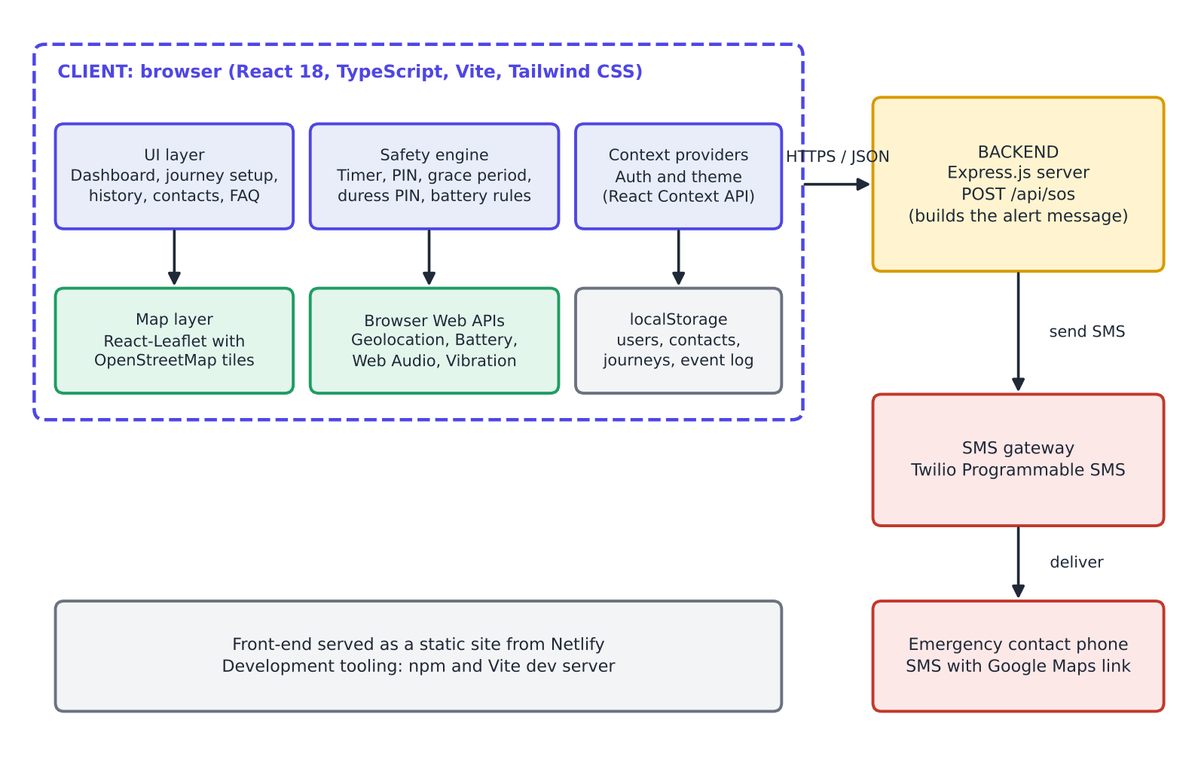
Figure 3.1: Logical architecture of Women Safety Tracker
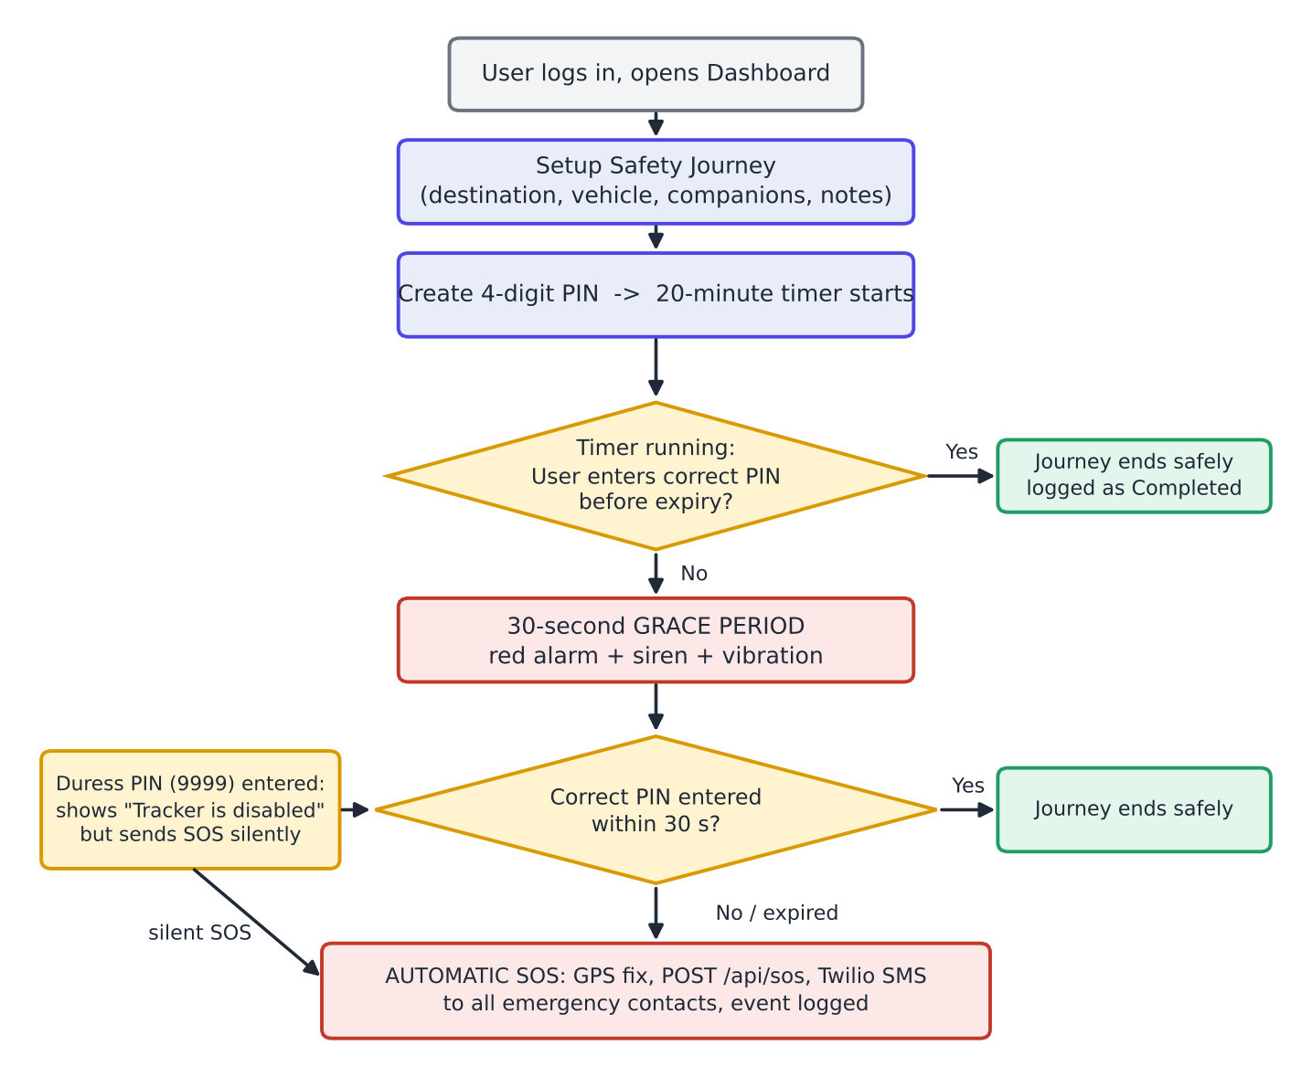
Figure 3.2: Journey workflow: from set-up to safe completion or automatic SOS
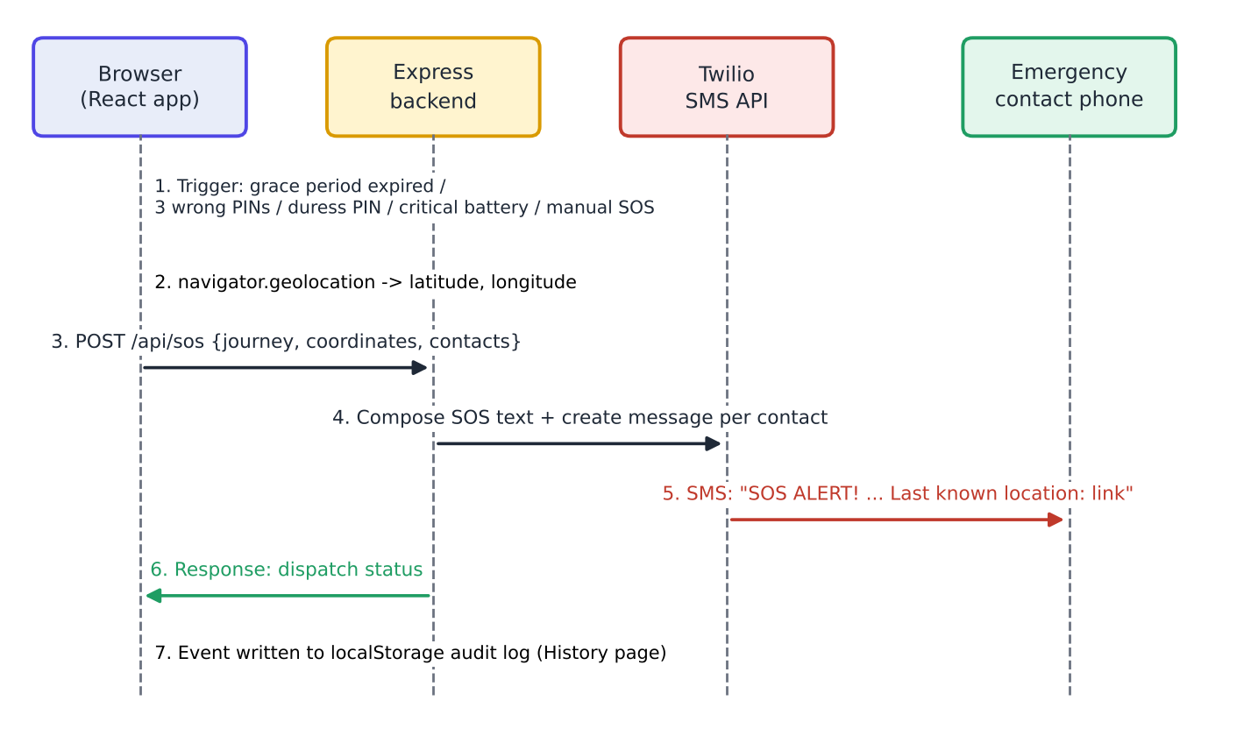
Figure 3.3: Sequence of an SOS dispatch
The three wrong-PIN rule sits on top of this flow: a first wrong PIN shows an error, a second warns that the next failure will send an SOS, and a third sends the SOS immediately.

3.5 Tools and Technologies Used
Table 3.3: Technology stack
Layer | Technology | Purpose
Front end | React 18 with TypeScript | Component-based, type-safe user interface [12], [13]
Build tool | Vite | Fast development server and optimised production bundle [14]
Styling | Tailwind CSS | Utility-first, responsive, theme-aware styling [15]
Maps | React-Leaflet, OpenStreetMap | Interactive map, markers and route display [16], [17]
State | React Context API | Global authentication and theme state
Back end | Node.js, Express.js | REST endpoint /api/sos that builds and dispatches the alert [18]
Messaging | Twilio Programmable SMS | Delivery of SOS text messages to contacts [10]
Storage | Browser localStorage | Credentials, contacts, journeys and event log [19]
Hosting | Netlify | Static hosting of the front end [23]

Table 3.4: Browser APIs used and their role
API | Role in the system | Compatibility note
Geolocation | Latitude and longitude for the SOS link and the Location Hub [6] | Needs user permission and a secure (HTTPS) context
Battery Status | Low-battery warning and critical-battery SOS [7] | Available mainly in Chromium-based browsers
Web Audio | Synthesised siren during the grace period [8] | Browsers require prior user interaction before sound
Vibration | Haptic feedback during the alarm [9] | Not available on iOS browsers
Web Storage | Persisting data on the device [19] | Per-browser; cleared if site data is cleared

3.6 Algorithm / Model Description
The system is rule-based and deterministic; it does not use a machine-learning model. Its behaviour is defined by three small algorithms, given here as pseudocode that describes the implemented logic.
Algorithm 3.1: Journey timer, PIN check and grace period
on StartJourney(details, pin):
attempts <- 0 ; remaining <- 20 minutes ; state <- ACTIVE
every second while state = ACTIVE:
remaining <- remaining - 1
if remaining = 0: state <- GRACE ; remaining <- 30 s ; start alarm
every second while state = GRACE:
remaining <- remaining - 1
if remaining = 0: SendSOS(reason = "timer expired")
on PinEntered(x): // ACTIVE or GRACE
if x = DURESS_PIN: show "Tracker is disabled" ; SendSOS("duress")
else if x = pin: stop alarm ; state <- COMPLETED ; log event
else: attempts <- attempts + 1
if attempts = 2: warn "next failure sends SOS"
if attempts = 3: SendSOS("3 wrong PINs")

Algorithm 3.2: SOS dispatch
function SendSOS(reason):
pos <- navigator.geolocation.getCurrentPosition()
payload <- { journey, contacts, lat: pos.lat, lng: pos.lng, reason }
POST /api/sos with payload
// back end:
text <- "SOS ALERT! " + notes + ". Traveling in " + vehicle
+ " to " + destination + " with " + companions
+ ". Last known location: https://maps.google.com/?q=lat,lng"
for each contact: twilio.messages.create(to = contact.phone, body = text)
append event to audit log

Algorithm 3.3: Battery monitor
on BatteryLevelChange(level):
if level <= 15%: show "Battery low" warning
if level <= 5% and journey is ACTIVE:
show "Battery critical" ; SendSOS("critical battery")

A design choice worth noting is that the "Tracker is disabled" screen is identical for the genuine PIN and the duress PIN. An attacker watching the screen therefore cannot tell which was entered.

Chapter 4: Implementation

4.1 Dataset / Data Collection
The system does not use a pre-existing dataset and does not train a model. All data are produced at run time, either typed in by the user or read from the device. Table 4.1 lists the data entities handled by the application.
Table 4.1: Data entities and their sources
Entity | Fields | Source
User account | Sign-in identity and credentials | Sign-in form
Emergency contact | Name, relationship, phone number | Contact Directory form
Journey | Destination, vehicle / mode of transit, companions, notes, 20-minute timer, status | Journey set-up form
Location sample | Latitude, longitude, time, accuracy | Geolocation API
Device state | Battery level and charging status | Battery Status API
Safety event | Type (for example SOS transmission, journey completed), time, status | Generated by the safety engine

4.2 Data Pre-processing
Because the data are small and structured, pre-processing consists of validation and formatting rather than cleaning. The PIN is restricted to four digits through the on-screen keypad. The coordinates returned by the Geolocation API are formatted into a Google Maps query link of the form https://maps.google.com/?q=<latitude>,<longitude>, which opens on any phone. The journey fields are merged into one human-readable sentence for the SMS body, and phone numbers must be held with their country code because Twilio addresses recipients in international format [10]. Before an SOS is sent, a fresh position is requested so that the alert carries the most recent fix.

4.3 Model Development / System Design
The application was designed as a small state machine with the states Idle, Set-up, Active, Grace, Completed and SOS sent, driven by timer ticks, PIN entries and device events as described in Section 3.6. The user interface is split into feature components (dashboard, journey set-up, PIN pad, alarm, contacts, history, location hub, route settings and FAQ), shared state for authentication and theme is held in React Context providers, and all device-API access is isolated in small helper modules so that the safety engine can be tested without a physical device. The back end is deliberately minimal: a single Express.js route receives the SOS payload, builds the message and calls Twilio, and the same pattern could be extended to further routes without changing the front end.

4.4 Implementation Details

4.4.1 Landing page and feature overview
The landing page introduces the product under the tagline "Travel Smarter. Stay Safer." and offers a call-to-action to start a journey. A feature section titled "Engineered for Vigilance" presents One-Tap SOS, Trusted Circle, Fake Decoy Calls, Safe Routes and Journey Tracker.
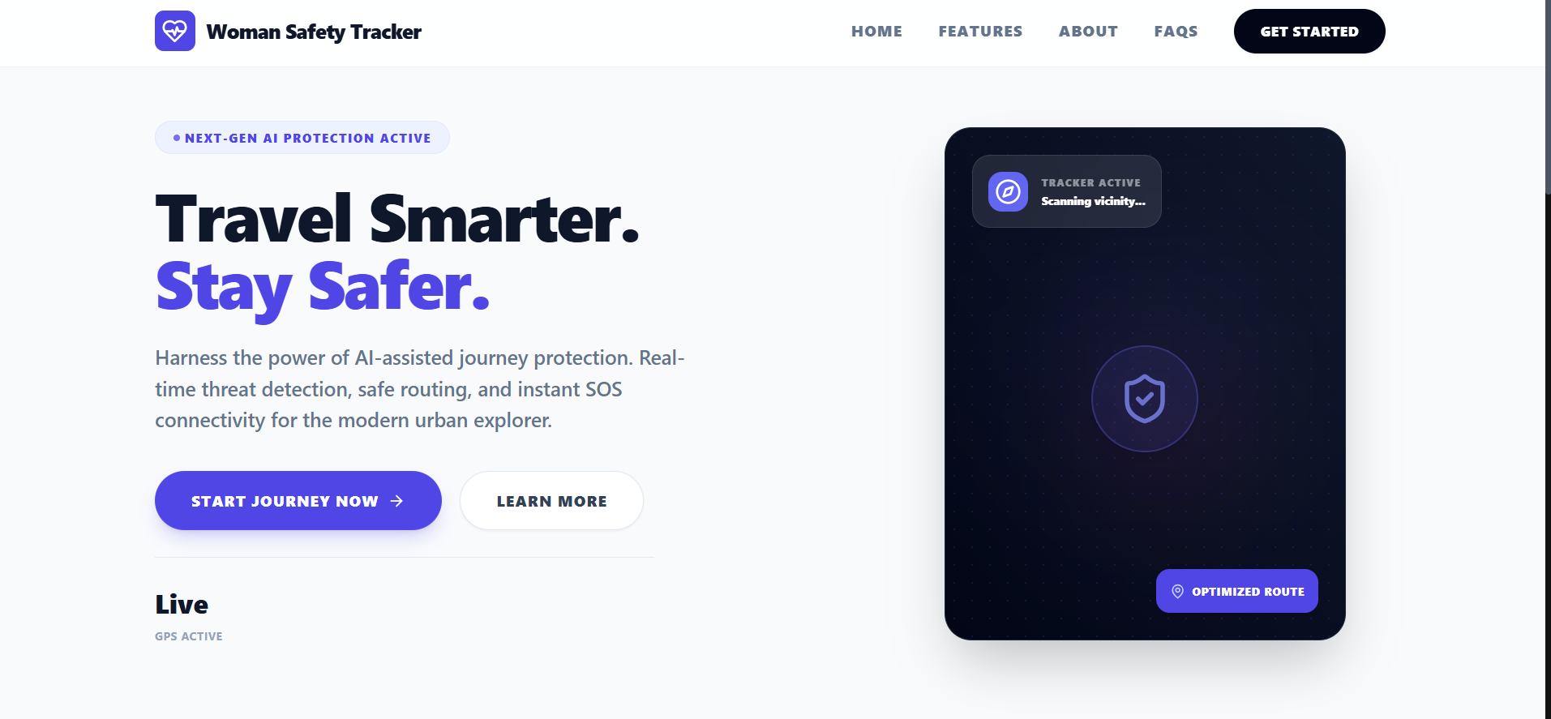
Figure 4.1: Landing page of Women Safety Tracker
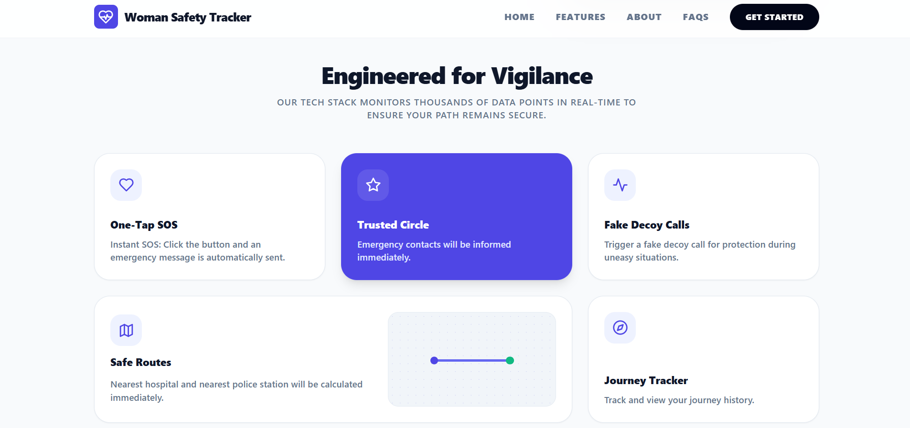
Figure 4.2: "Engineered for Vigilance" feature section

4.4.2 Dashboard
After sign-in the user lands on the dashboard, which combines journey statistics, the number of emergency contacts, a safety score, a live map with the current location, a card to set up and start a new journey, and shortcuts for the decoy call and for sharing coordinates. A side navigation moves between the map dashboard, active journey, history, emergency contacts and location hub.
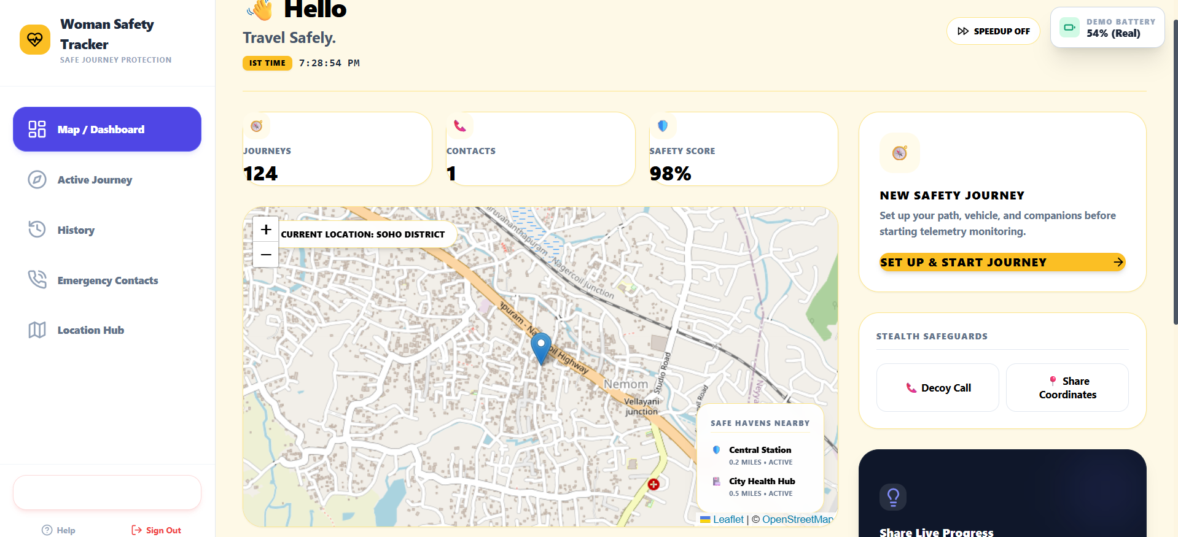
Figure 4.3: User dashboard with map and journey controls

4.4.3 Journey set-up
Selecting "Set up and start journey" opens the Setup Safety Journey form. The user chooses the destination and enters the vehicle or mode of transit, the companions and any notes. The estimated arrival time is fixed at a 20-minute journey timer, shown as "primed". The button "Proceed to PIN Security" moves to the PIN screen.
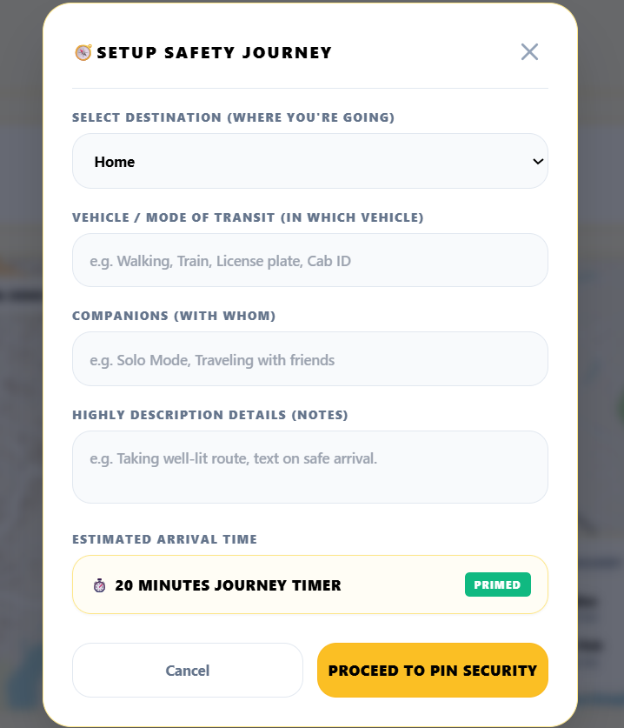
Figure 4.4: Setup Safety Journey form

4.4.4 PIN security and alarm state
On the PIN screen the user chooses a four-digit PIN on a large on-screen keypad. This PIN is the only way to end a running journey. When the 20-minute timer expires, the application enters the alarm state: a full-screen red warning with a 30-second countdown, a siren synthesised with the Web Audio API and vibration through the Vibration API. The user must enter the PIN to reset the timer.
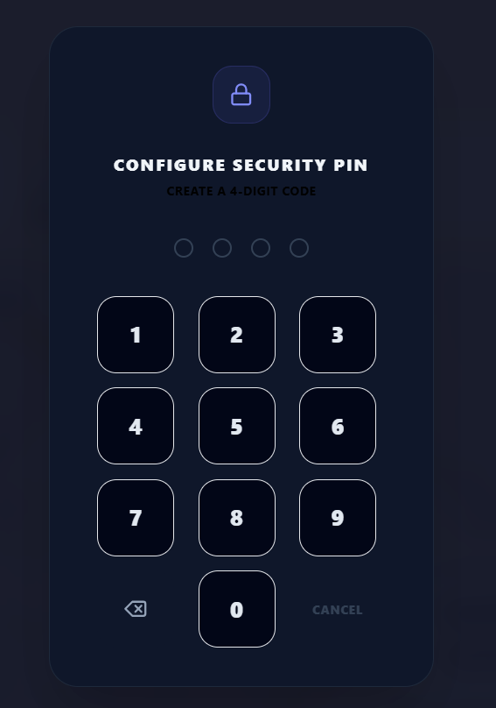 | 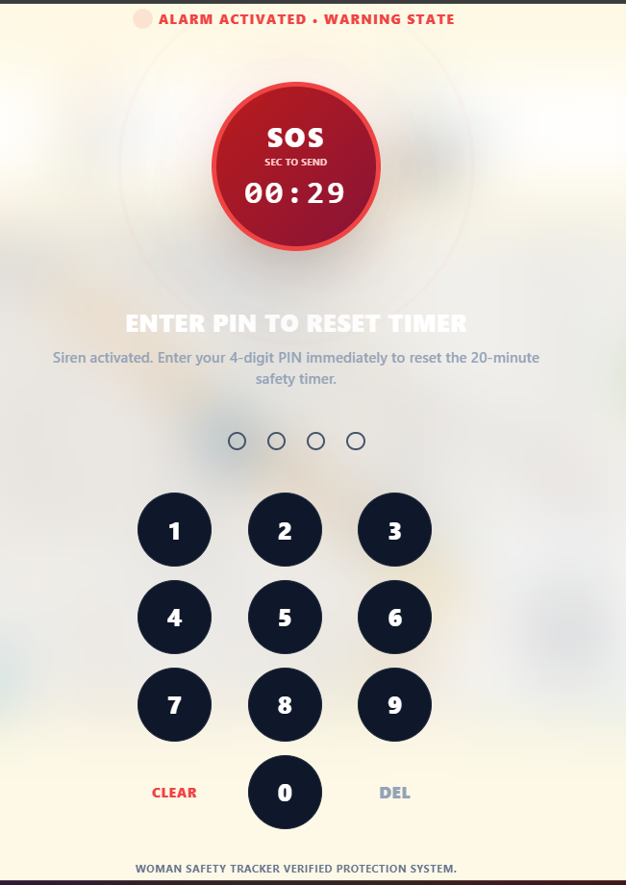
Figure 4.5: PIN configuration screen (left) and active alarm state with SOS countdown (right)

4.4.5 Duress PIN (stealth mode)
If the user is forced to switch the tracker off, she can enter the duress PIN (9999 in the current build) instead of her real PIN. The application shows the same "Tracker is disabled" confirmation as for a genuine PIN, so the attacker believes the tracker has been stopped, while an SOS is sent to all emergency contacts in the background.
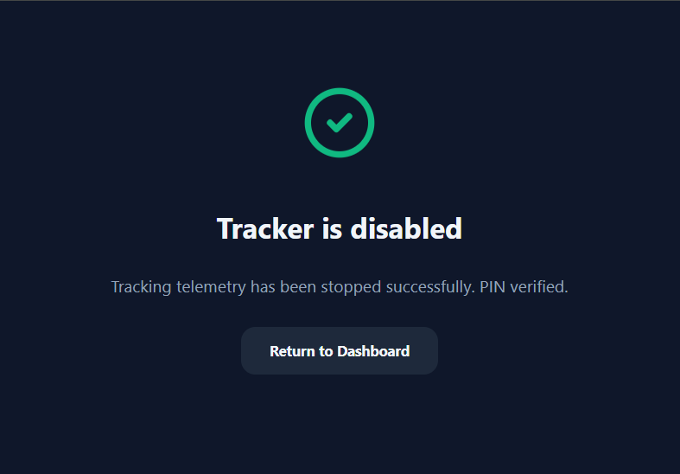
Figure 4.6: "Tracker is disabled" screen shown for the genuine PIN and for the duress PIN

4.4.6 FAQ and in-app help
A FAQ section explains how the system works, what the duress PIN does and what happens when the battery is low, so that a new user understands the safety logic before relying on it.
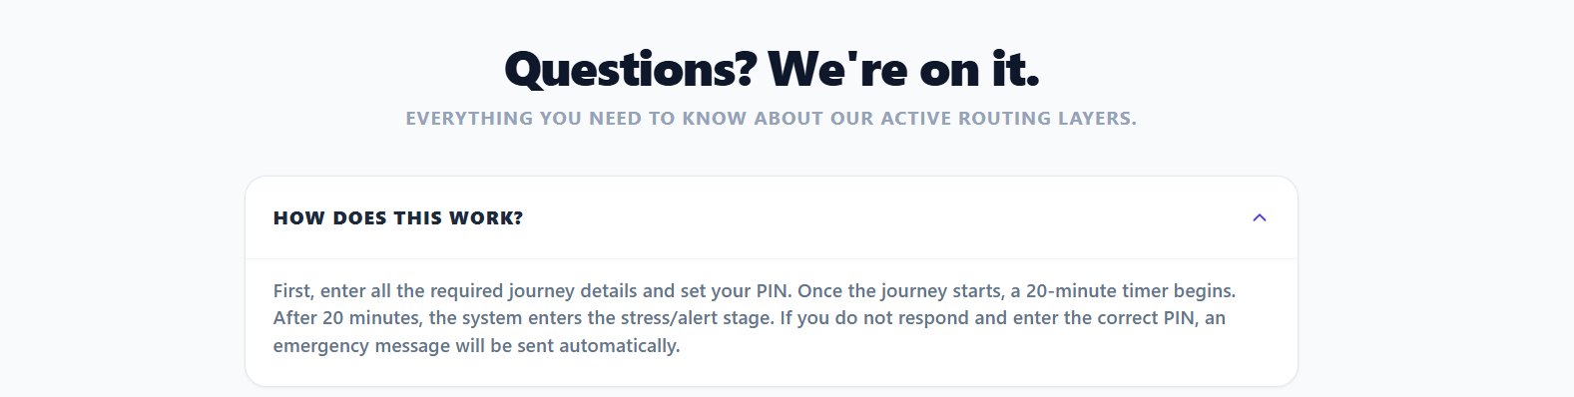
Figure 4.7: FAQ entry explaining how the journey workflow works
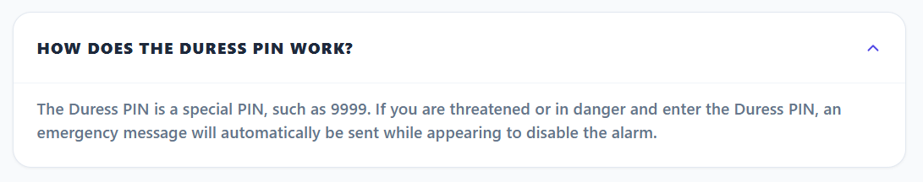
Figure 4.8: FAQ entry explaining the duress PIN
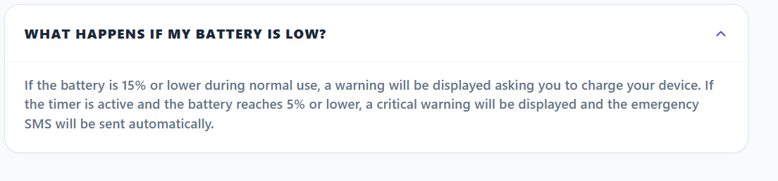
Figure 4.9: FAQ entry explaining low-battery behaviour

4.4.7 Battery monitoring
The Battery Status API is used to watch the charge level. Two thresholds are applied (Table 4.2). At 15% or lower a "Battery low" dialog asks the user to charge the device. At 5% or lower during an active journey a "Battery critical" screen is shown and an SOS message is sent automatically, so that contacts are informed before the phone switches off.
Table 4.2: Battery alert levels
Level | Condition | Action
Low | Battery at 15% or lower | Dialog "Battery low" with Acknowledge button
Critical | Battery at 5% or lower and a journey is active | "Battery critical" screen and automatic SOS SMS

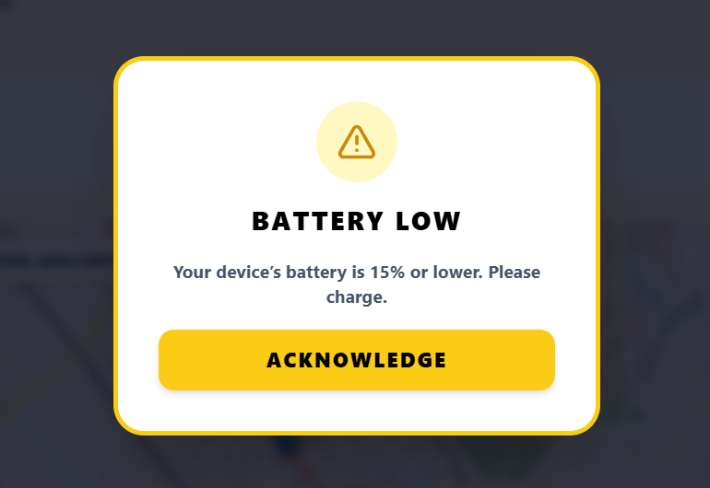
Figure 4.10: Battery low warning
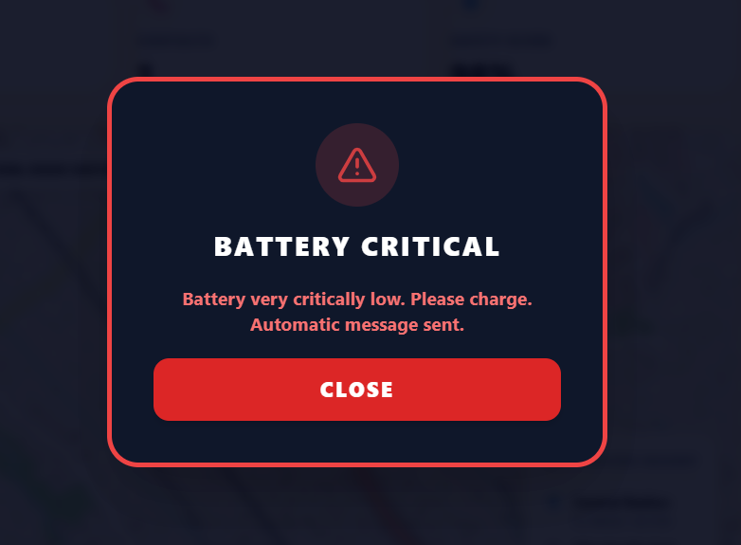
Figure 4.11: Battery critical warning with automatic SOS

4.4.8 Safe routes and emergency facilities
The Route Settings page lets the user choose a hospital or a police station as the emergency target. The application finds the nearest facility on the OpenStreetMap-based map, draws the route and shows its distance and a walking-time estimate. Figure 4.12 shows a hospital route and Figure 4.13 a police-station route.
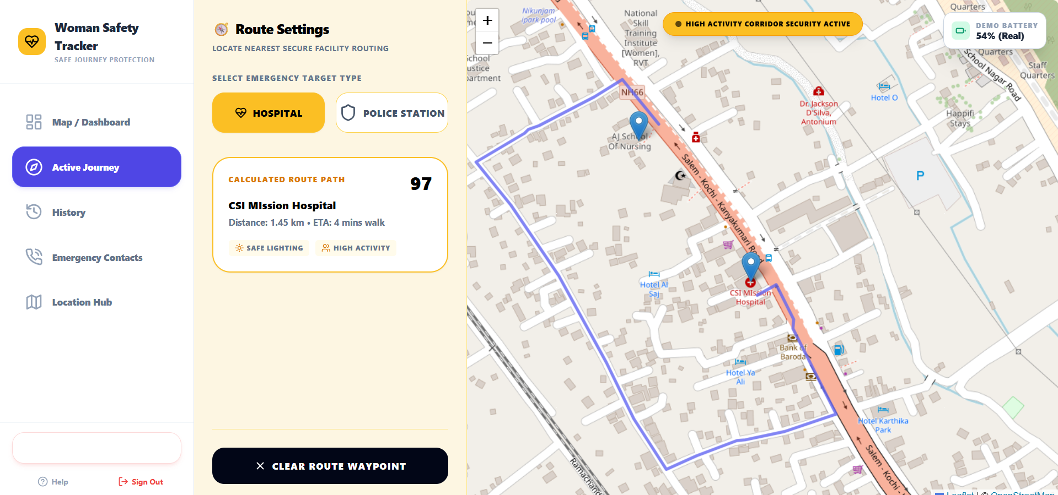
Figure 4.12: Safe route to the nearest hospital
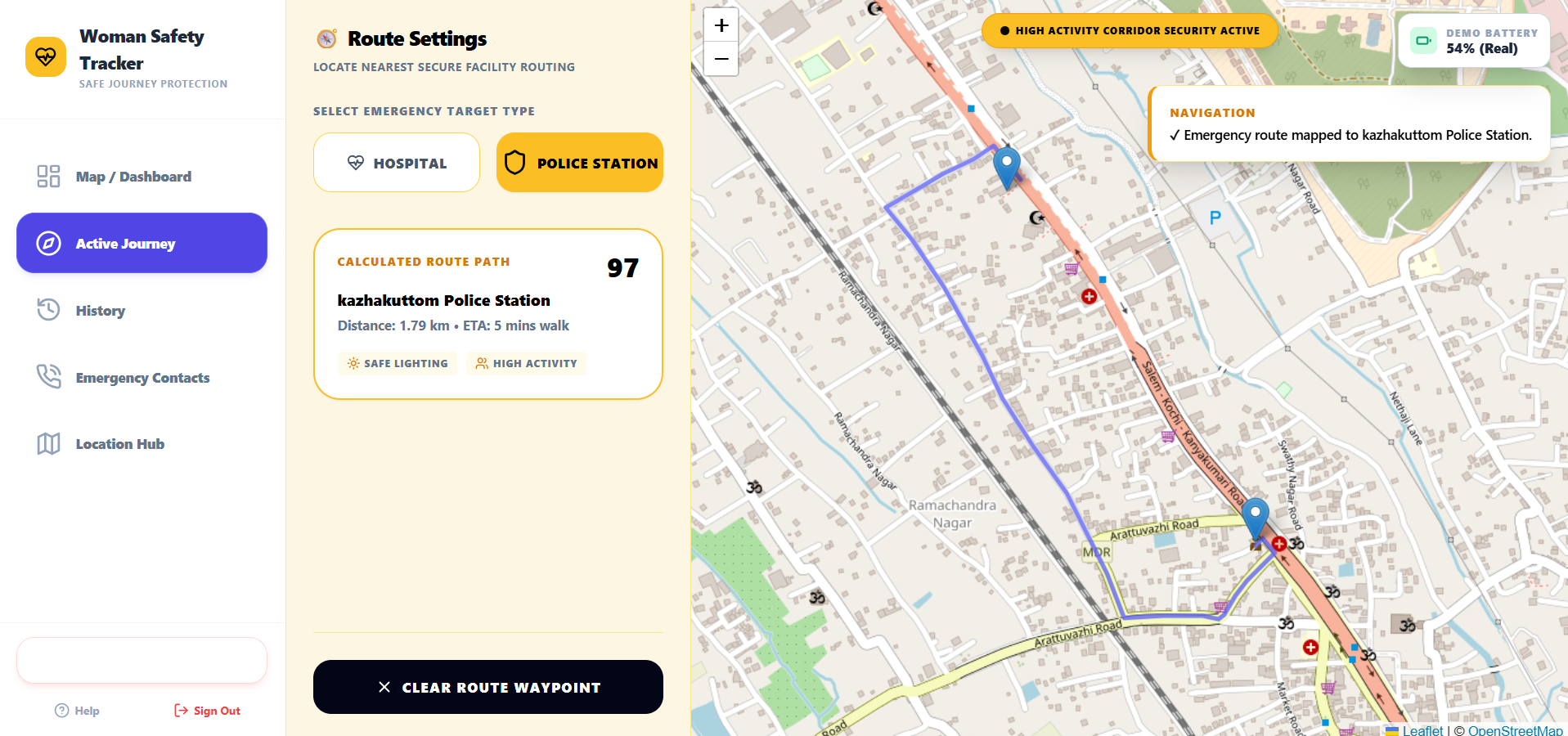
Figure 4.13: Safe route to the nearest police station

4.4.9 History, contacts and location hub
The Safety Log and Audit History page records every journey and safety event with its time and status, and shows summary counts for total journeys, alerts dispatched, active days and check-ins. The Contact Directory is where the user adds the people who will receive SOS messages, with name, relationship and number. The Location Hub shows the live position on the map, the exact coordinates, a log of recent location samples and the reported accuracy, and offers buttons to get the GPS location and to share the live position.
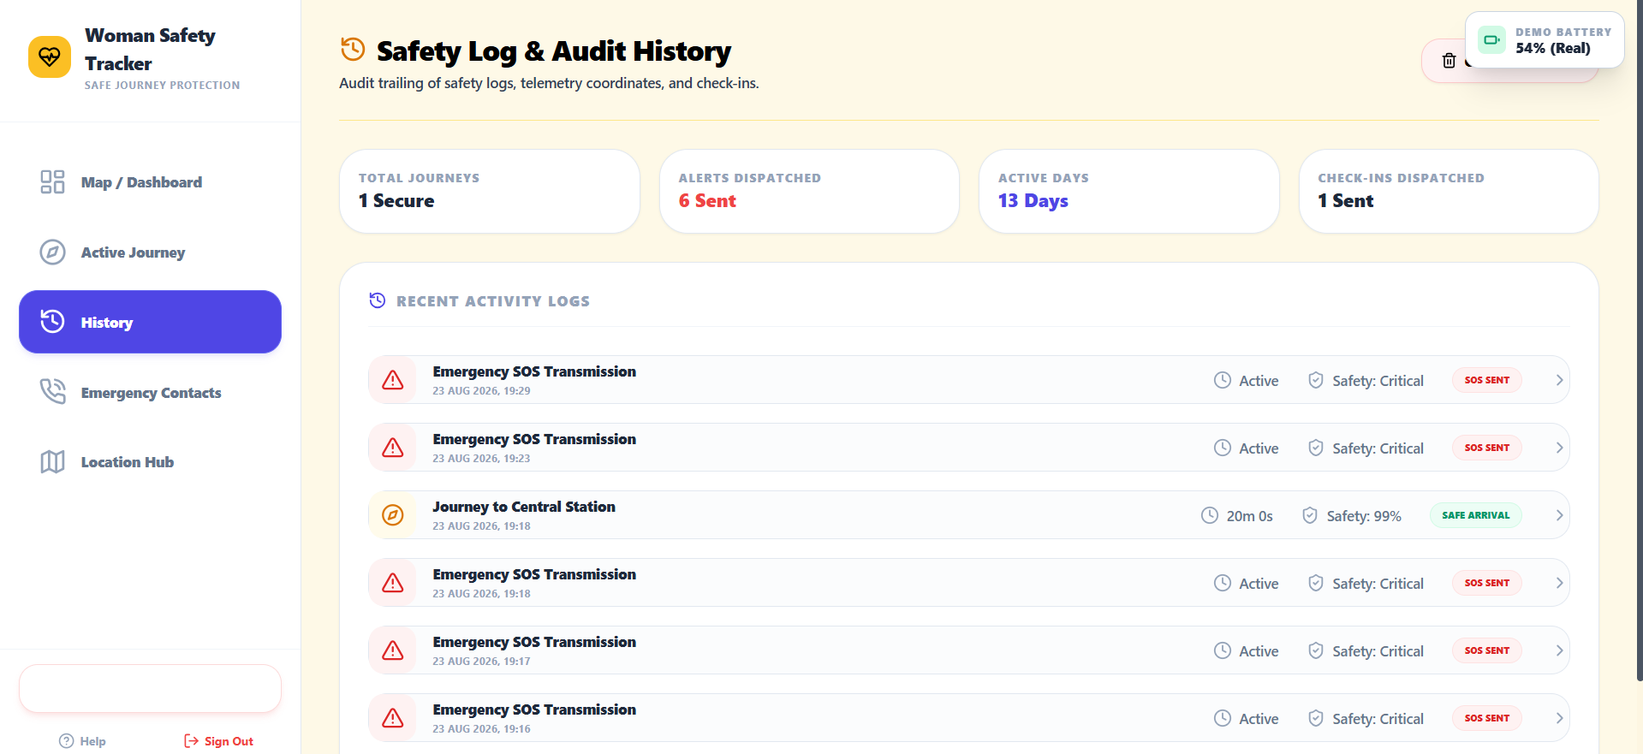
Figure 4.14: Safety log and audit history
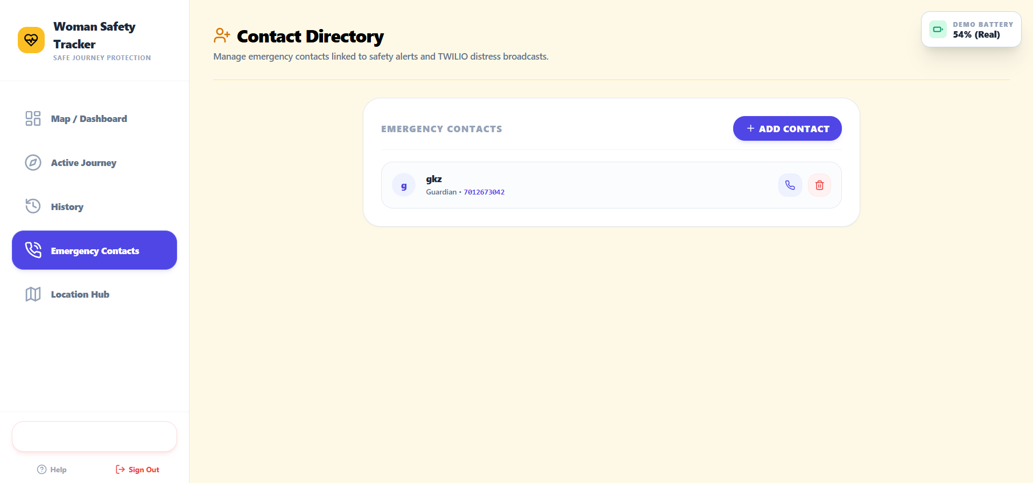
Figure 4.15: Emergency contact directory
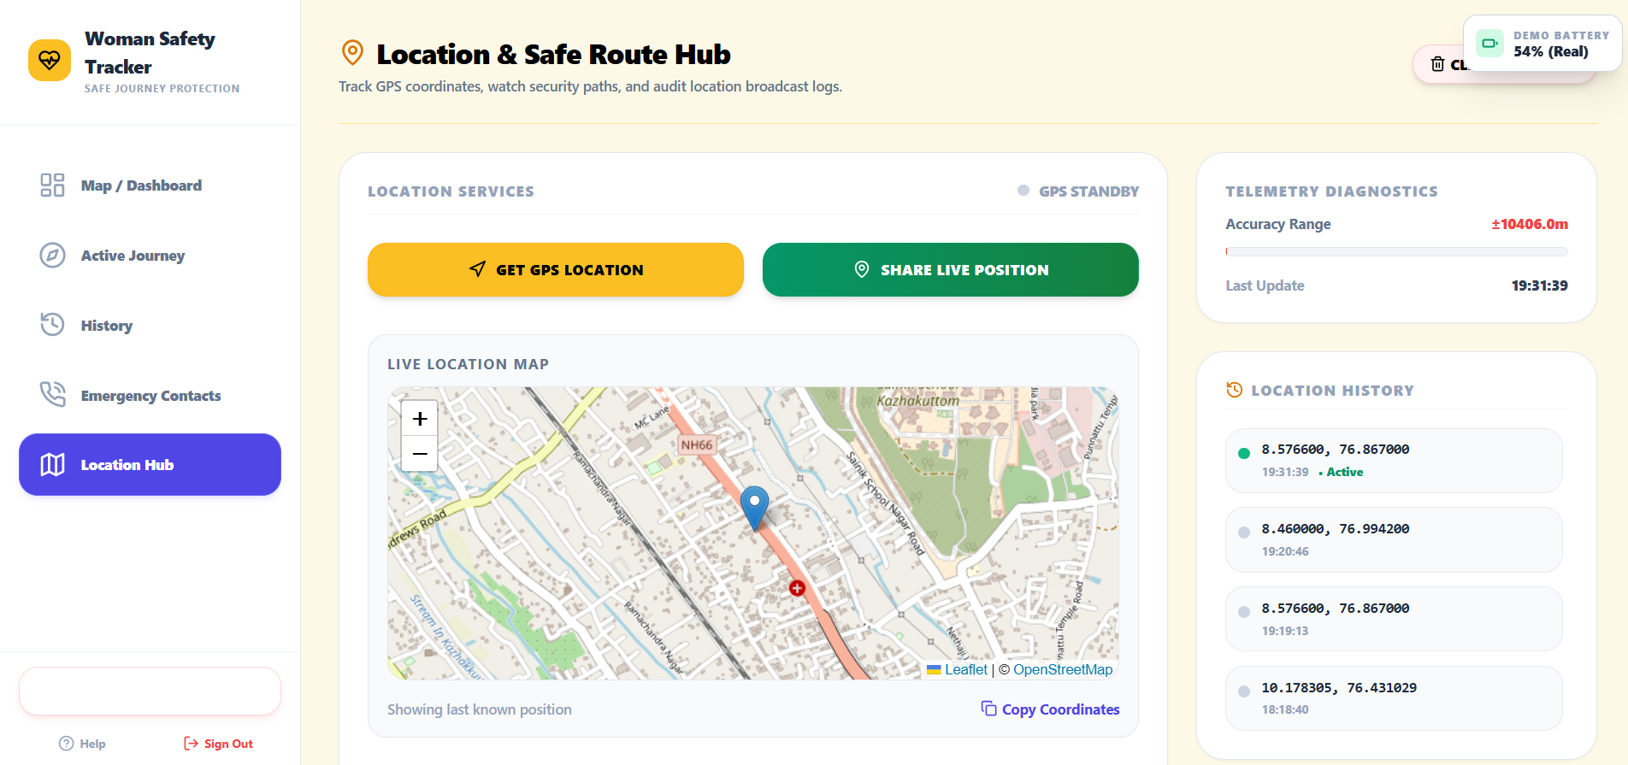
Figure 4.16: Location Hub with live map and location history

4.4.10 Decoy call
The decoy call feature schedules a fake incoming call at a time chosen by the user. When it fires, the application simulates a ringing call, giving the user a natural excuse to leave an uncomfortable situation.

4.4.11 SOS dispatch and SMS composition
Every trigger listed in Table 4.3 calls the same dispatch routine. It reads the position, posts the journey details and coordinates to /api/sos, and the back end sends one SMS per emergency contact through Twilio. The message begins with "SOS ALERT!", states the notes, vehicle, destination and companions, and ends with a Google Maps link to the last known location. Each event is also written to the audit log.
Table 4.3: Conditions that trigger an SOS
No. | Trigger | Description
1 | Grace period expired | The timer ran out and no correct PIN was entered within 30 seconds.
2 | Three wrong PINs | The third incorrect PIN attempt sends the SOS at once.
3 | Duress PIN | The reserved PIN is entered; a "disabled" screen is shown and the SOS is sent silently.
4 | Critical battery | Battery at 5% or lower during an active journey.
5 | Manual SOS | The user presses the SOS control at any time.

4.4.12 Deployment
The front end is built with Vite and published as a static site on Netlify at https://woman-safety-app.netlify.app/ [23]. During development the application is started locally with npm run dev.

4.5 Experimental Setup
The application was exercised in a desktop web browser. SMS messages were sent through a Twilio trial account to a verified recipient number; the SMS was read on an Android phone in the Google Messages application (Figure 5.2). A trial account can send only to verified numbers and adds a "Sent from your Twilio trial account" prefix to messages [24]. The journey used for the main test is shown in Figure 5.1: destination Home; vehicle "Uber Mruti Swift KL 0909"; companion "Samuel (college friend)"; notes "Coming back Home after college"; 20-minute timer.

Chapter 5: Results and Discussion

5.1 Performance Evaluation Metrics
Because the system is a rule-based safety application, evaluation is functional rather than statistical. The metrics in Table 5.1 were chosen to answer the question that matters most: does a missed check-in reliably become an informative alert on a contact’s phone?
Table 5.1: Evaluation metrics
Metric | Definition | How it was assessed
Trigger correctness | Each trigger in Table 4.3 produces the specified behaviour | Scenario tests (Table 5.2)
Alert completeness | The SMS contains purpose, vehicle, destination, companion and location | Inspection of received SMS (Table 5.3)
Delivery | The SMS reaches the emergency contact’s phone | Received on test handset (Figure 5.2)
Location fidelity | The link in the SMS opens the position recorded by the device | Coordinates in the SMS compared with the device fix
Usability | Effort needed to start a journey | Set-up needs one form and one PIN (Figures 4.4, 4.5)

5.2 Experimental Results

5.2.1 Functional test scenarios
Table 5.2 lists the scenarios together with the outcome supported by the screenshots in this report. "Not shown" and "Partial" mark behaviour that is implemented but not fully captured in the evidence.
Table 5.2: Test scenarios and observed results
ID | Scenario | Expected behaviour | Observed | Status
T1 | Set up a journey and create a PIN | Timer is primed at 20 minutes; journey starts after PIN | Form accepted; PIN screen shown (Figs 4.4, 4.5, 5.1) | Pass
T2 | Enter correct PIN during a journey | Alarm and timer stop | "Tracker is disabled" screen (Fig 4.6) | Pass
T3 | Let the timer expire without PIN | Grace-period alarm, then automatic SOS | Alarm shown; SOS SMS received (Figs 4.5, 5.2) | Pass
T4 | Enter three wrong PINs | Warning on 2nd, SOS on 3rd | Implemented per design; no screenshot captured | Not shown
T5 | Enter duress PIN 9999 | Fake "disabled" screen, silent SOS | Disabled screen is identical to genuine PIN (Fig 4.6); silent SOS not separately captured | Partial
T6 | Battery at 15% or lower | "Battery low" dialog | Dialog displayed (Fig 4.10) | Pass
T7 | Battery at 5% or lower during journey | "Battery critical" and automatic SOS | Critical screen displayed (Fig 4.11) | Pass
T8 | Choose hospital / police station | Nearest facility, route and distance | Route drawn (Figs 4.12, 4.13) | Pass
T9 | Add contact; view history | Contact saved; events logged | Shown in directory and audit log (Figs 4.14, 4.15) | Pass
T10 | Open Location Hub | Live position, coordinates, history | Map and coordinates shown (Fig 4.16) | Pass

5.2.2 End-to-end SOS test
The most important result is the complete chain from the journey in Figure 5.1 to the SMS in Figure 5.2. A journey was configured with the test data shown, and an SOS was dispatched. The emergency contact’s phone received an SMS with the journey context and a Google Maps link.
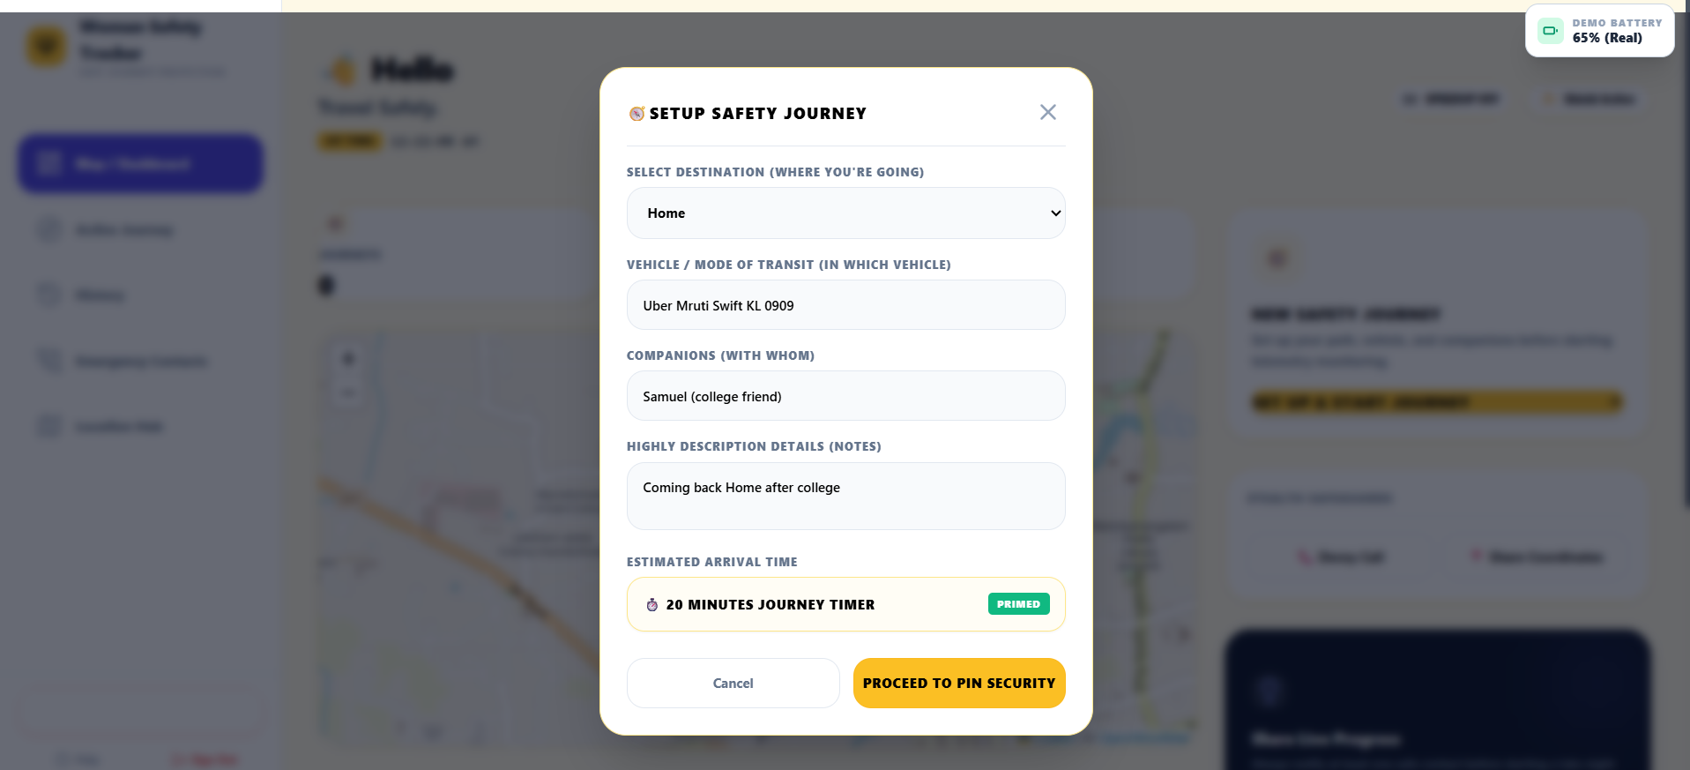
Figure 5.1: Journey set-up with test data (destination Home, Uber, companion Samuel)
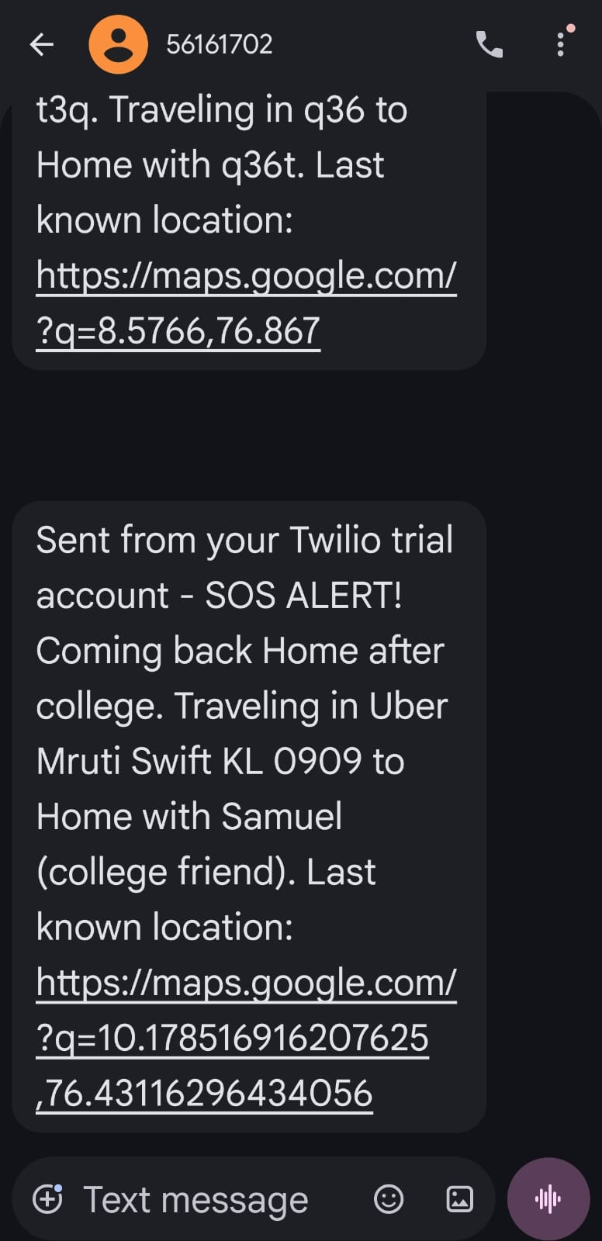
Figure 5.2: SOS SMS received on the emergency contact’s phone (earlier test message above, main test below)
Table 5.3: Content of the received SOS SMS
Element | Value in the received message
Trial-account prefix | Sent from your Twilio trial account (added by Twilio)
Alert header | SOS ALERT!
Notes | Coming back Home after college
Vehicle | Uber Mruti Swift KL 0909
Destination | Home
Companion | Samuel (college friend)
Location link | https://maps.google.com/?q=10.178516916207625,76.43116296434056

The SMS reproduces every field entered in the set-up form and adds a tappable location link, so the recipient understands who is in danger, in which vehicle, with whom, and where, without opening any application. The figure also shows an earlier test message with throw-away text in the fields, which indicates that the dispatch path was exercised more than once during development.

5.3 Comparative Analysis
Table 5.4 compares the proposed system with the two approaches most commonly found in the literature and in deployed applications. The comparison is made at the level of approach rather than product, because individual applications differ widely and change their features over time.
Table 5.4: Comparison of approaches (general characteristics)
Criterion | Manual SOS approach | Live-sharing approach | Women Safety Tracker
Trigger | User action | None (watcher must notice) | Missed check-in, plus user action
Helps if user cannot act | No | Only if watched | Yes
Covert distress signal | Rarely | No | Yes (duress PIN)
Alert carries journey context | Seldom | Location trail only | Yes
Recipient must install an app | Often | Often | No (SMS)
Installation for the user | Native app | Native app | None (web)
Works when the phone is locked | Usually | Usually | Limited (see Section 5.4)

5.4 Discussion
What the results show. The tests demonstrate that a missed check-in is converted into an informative SMS without any further action by the user, and that each of the five triggers reaches the same dispatch routine. The design choice of making the real and duress confirmations look identical gives the user a covert channel that manual-SOS tools do not offer.
Location accuracy. The coordinates in the SMS carry 15 decimal digits, which looks very precise but is only the raw output of the Geolocation API. The real accuracy is set by the device’s positioning source, typically some metres with GPS and much worse with network positioning, and the API reports this accuracy value separately [6]. The Location Hub therefore displays an accuracy reading, and a future version should also include it in the SMS.
Threats to validity. The evaluation is a functional test by the developer on a small number of devices; it is not a field trial, and no formal user study was carried out. The SMS path was proven with a Twilio trial account, which restricts recipients to verified numbers [24]. The test results should therefore be read as evidence that the design works end to end, not as a measure of real-world reliability.
Key limitation of the web approach. The timer and the alarm run inside a browser page. Browsers may throttle or suspend pages that are in the background or when the phone is locked, and the alert cannot be sent if the device is switched off or loses connectivity. A server-side timer, a progressive web app or a native application would be needed for dependable operation in the background; this is the most important item of future work.

Chapter 6: Conclusion and Future Scope

6.1 Summary of Work
During the internship, a web-based journey protection system, Women Safety Tracker, was designed, implemented, deployed and tested. The system turns a journey into a monitored session protected by a PIN and a 20-minute timer, escalates through a 30-second alarm to an automatic SOS, and offers a covert duress PIN for coercion. Alerts are delivered as SMS messages containing the journey details and a Google Maps link, so contacts need no application. Supporting features include battery monitoring, a decoy call, safe-route guidance to hospitals and police stations, a contact directory, a location hub and an audit log.

6.2 Outcomes Achieved
- A working, deployed web application with a responsive interface, available at https://woman-safety-app.netlify.app/.
- A proactive safety workflow (timer, grace period, automatic SOS) that does not depend on the user pressing an SOS button.
- A covert duress-PIN mechanism whose confirmation screen is indistinguishable from a genuine disable.
- Five independent SOS triggers sharing one dispatch routine.
- End-to-end verification: an SOS SMS with journey context and a location link received on a mobile phone through Twilio.
- Experience with React, TypeScript, Tailwind CSS, Leaflet/OpenStreetMap, Express.js, Twilio and browser device APIs.

6.3 Limitations
- Browser-side timer: background throttling, a locked phone, a closed tab or no connectivity can prevent the SOS from being sent.
- Twilio trial account: SMS can be sent only to verified numbers and carries a trial prefix [24]; production use needs a paid account and compliance with Indian SMS sender-registration rules.
- Client-side data: accounts, contacts and logs are kept in browser storage, which is per-device, can be cleared, and is not suited to secrets such as PINs.
- Fixed duress PIN: the reserved duress code is the same for every user in the current build and could be guessed.
- Browser support: the Battery Status and Vibration APIs are not available in all browsers [7], [9].
- Positioning accuracy: browser location can be coarse indoors or with network positioning [6].
- Rule-based only: there is no learning component; the landing-page wording about intelligent protection refers to automated rules.
- Limited testing: developer testing on a few devices; no user study or field trial.

6.4 Future Enhancements
- Server-side timer and push notifications: keep the countdown on the server so that a missed check-in triggers an SOS even if the phone is locked or offline.
- Progressive web app or native app: background execution, installation and more reliable access to sensors.
- Proper authentication and storage: server-side database, hashed and per-user PINs, and a user-configurable duress PIN.
- Live location sharing: continuous location updates to contacts during a journey, with privacy controls, and accuracy included in the SMS.
- Offline queueing: store the SOS and send it as soon as connectivity returns.
- Integration with emergency services: forward alerts to the 112 service or local police control rooms [3].
- Production-grade messaging: paid Twilio account or an Indian SMS provider, plus WhatsApp or push fallbacks.
- Risk analytics: once real usage data exist, analyse routes and times to highlight higher-risk journeys.
- Localisation: Malayalam, Hindi and other languages.
- Wearable support and a formal usability study with target users.

References
[1] National Crime Records Bureau, Crime in India 2022, Ministry of Home Affairs, Government of India, New Delhi, 2023. [Online]. Available: https://ncrb.gov.in
[2] Drishti IAS, "NCRB’s Crime in India 2022 Report," Dec. 6, 2023. [Online]. Available: https://www.drishtiias.com/daily-updates/daily-news-analysis/ncrbs-crime-in-india-2022-report
[3] Government of India, "Emergency Response Support System (ERSS), 112 India." [Online]. Available: https://112.gov.in
[4] Safetipin, "Safetipin: making cities safer for women." [Online]. Available: https://safetipin.com
[5] bSafe, "bSafe: personal safety app." [Online]. Available: https://getbsafe.com
[6] MDN Web Docs, "Geolocation API." [Online]. Available: https://developer.mozilla.org/en-US/docs/Web/API/Geolocation_API
[7] MDN Web Docs, "Battery Status API." [Online]. Available: https://developer.mozilla.org/en-US/docs/Web/API/Battery_Status_API
[8] MDN Web Docs, "Web Audio API." [Online]. Available: https://developer.mozilla.org/en-US/docs/Web/API/Web_Audio_API
[9] MDN Web Docs, "Vibration API." [Online]. Available: https://developer.mozilla.org/en-US/docs/Web/API/Vibration_API
[10] Twilio, "Programmable Messaging documentation." [Online]. Available: https://www.twilio.com/docs/messaging
[11] SheThePeople, "Delhi Police launches Himmat Plus." [Online]. Available: https://shethepeople.tv/news/delhi-police-launches-himmat-plus
[12] Meta Open Source, "React documentation." [Online]. Available: https://react.dev
[13] Microsoft, "TypeScript documentation." [Online]. Available: https://www.typescriptlang.org/docs/
[14] Vite, "Vite: next generation front-end tooling." [Online]. Available: https://vite.dev
[15] Tailwind Labs, "Tailwind CSS documentation." [Online]. Available: https://tailwindcss.com/docs
[16] V. Agafonkin, "Leaflet: an open-source JavaScript library for mobile-friendly interactive maps." [Online]. Available: https://leafletjs.com
[17] OpenStreetMap Foundation, "OpenStreetMap." [Online]. Available: https://www.openstreetmap.org/copyright
[18] OpenJS Foundation, "Express: fast, unopinionated, minimalist web framework for Node.js." [Online]. Available: https://expressjs.com
[19] MDN Web Docs, "Web Storage API." [Online]. Available: https://developer.mozilla.org/en-US/docs/Web/API/Web_Storage_API
[20] D. Chand, S. Nayak, K. S. Bhat, S. Parikh, Y. Singh, and A. A. Kamath, "A mobile application for women’s safety: WoSApp," in Proc. IEEE Region 10 Annu. Int. Conf. (TENCON), 2016. [Online]. Available: https://idr.nitk.ac.in/handle/123456789/7014
[21] "Abhaya: An Android App for the safety of women," IEEE Xplore. [Online]. Available: https://ieeexplore.ieee.org/document/7443652
[22] "Women Safety-Saviour Android Application," IEEE Xplore. [Online]. Available: https://ieeexplore.ieee.org/document/9823496
[23] Netlify, "Netlify documentation." [Online]. Available: https://docs.netlify.com
[24] Twilio, "How to use your free trial account." [Online]. Available: https://www.twilio.com/docs/messaging/guides/how-to-use-your-free-trial-account

Appendix

A. Sample Input and Output
Sample input (Setup Safety Journey form, Figure 5.1):
Table A.1: Sample journey input
Field | Value entered
Select destination | Home
Vehicle / mode of transit | Uber Mruti Swift KL 0909
Companions | Samuel (college friend)
Notes | Coming back Home after college
Estimated arrival time | 20-minute journey timer
PIN | Four digits chosen by the user

Sample output (SMS received by the emergency contact, Figure 5.2):
Sent from your Twilio trial account - SOS ALERT! Coming back Home
after college. Traveling in Uber Mruti Swift KL 0909 to Home with
Samuel (college friend). Last known location:
https://maps.google.com/?q=10.178516916207625,76.43116296434056

B. Running the Application
- Live deployment: https://woman-safety-app.netlify.app/
- Local development: install dependencies with npm install and start the development server with npm run dev.
- Demo account for testing: e-mail demo@womensafety.com, password demo123.
- SMS dispatch needs the Express.js back end running with valid Twilio credentials (account SID, auth token and sender number) supplied as environment variables, and recipient numbers verified on the Twilio trial account.

C. User Interface Screenshots
All user-interface screenshots of the application are included in Chapter 4 (Figures 4.1 to 4.16) and in Chapter 5 (Figures 5.1 and 5.2).

